After logging into the system, with login and password provided by the Executive Director, this screen with be visible.
Select Expanded Scan Out/Inventory Transfers
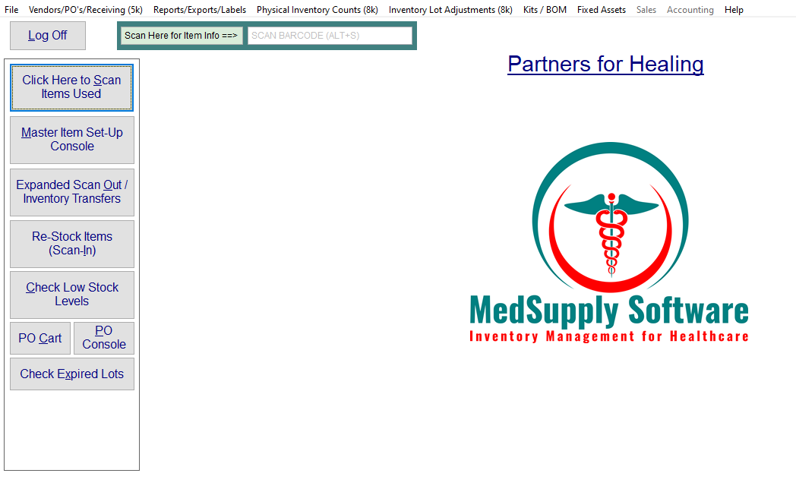The screen below will be displayed. The Password entered on login will be required again before medication can be dispensed.
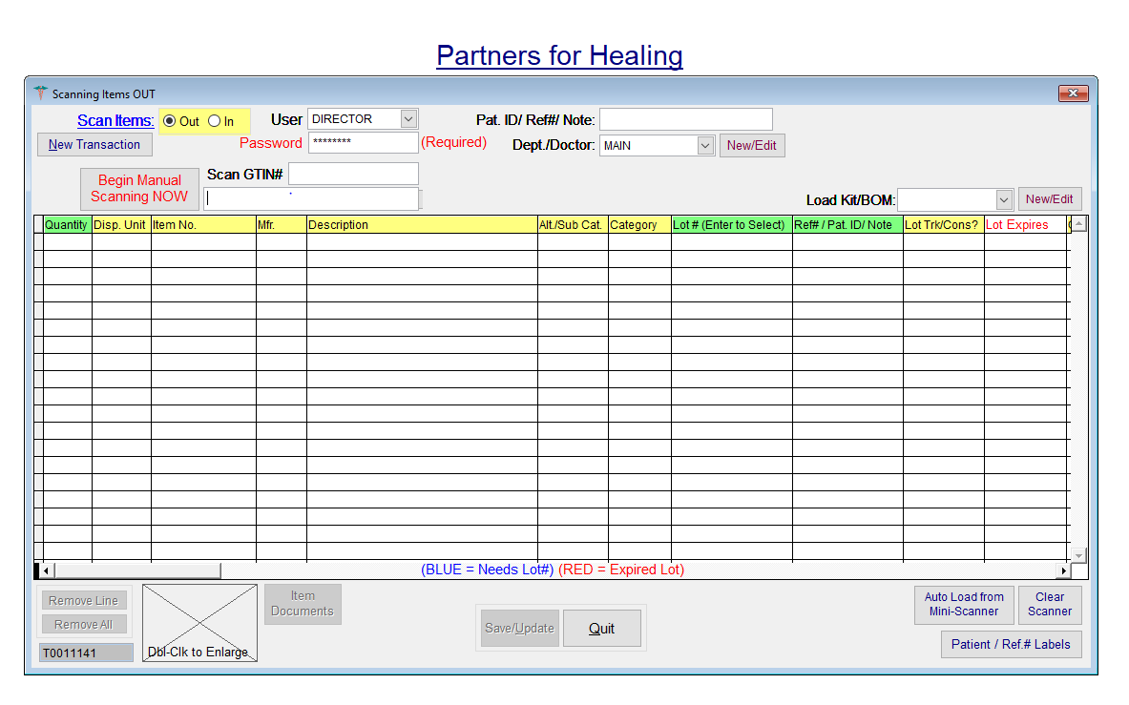
Enter a portion of the medication name in the Begin Manual Scanning NOW field
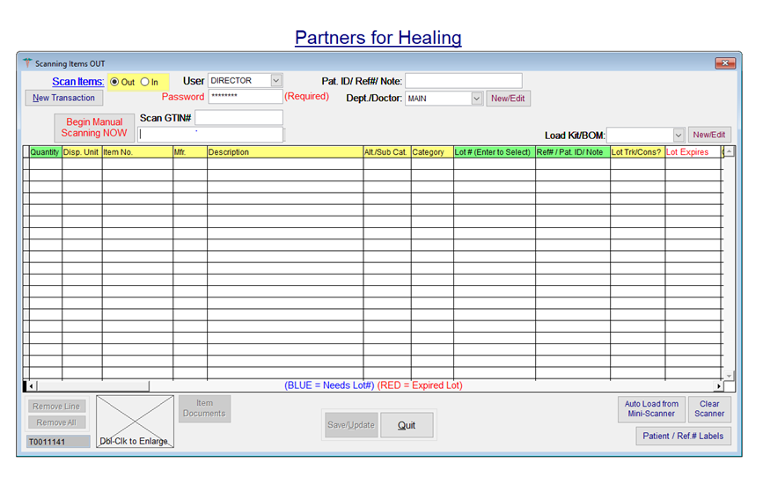
Any medications matching the entry will be displayed. If the exact name or reference number is known, it can be entered and the Scanning Item OUT screen will displayed
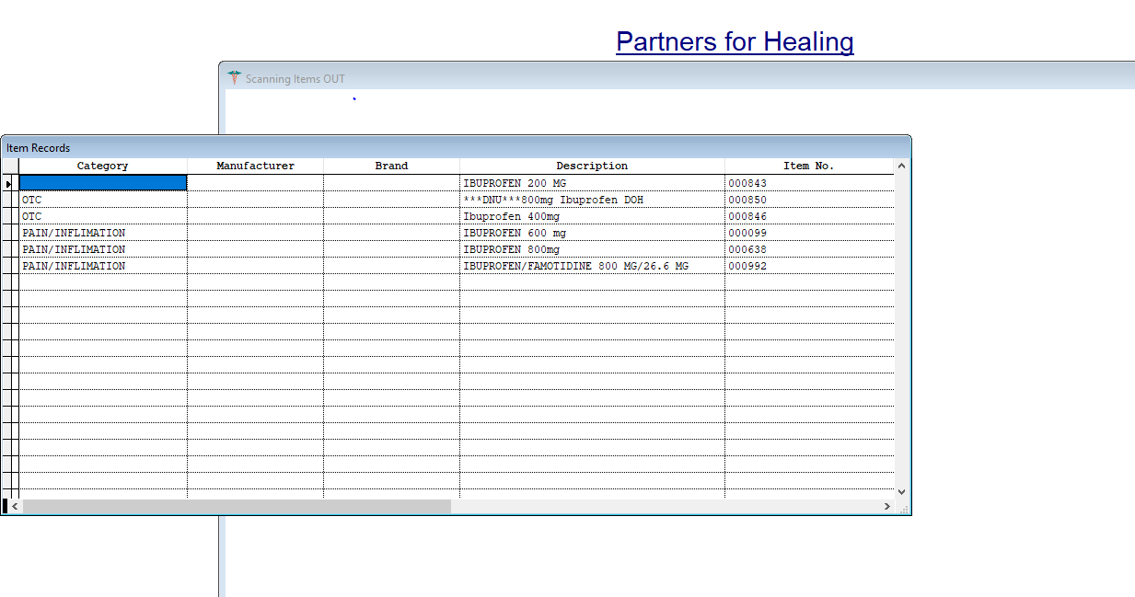
Select the name and correct dosage from the list and the screen below will be displayed.
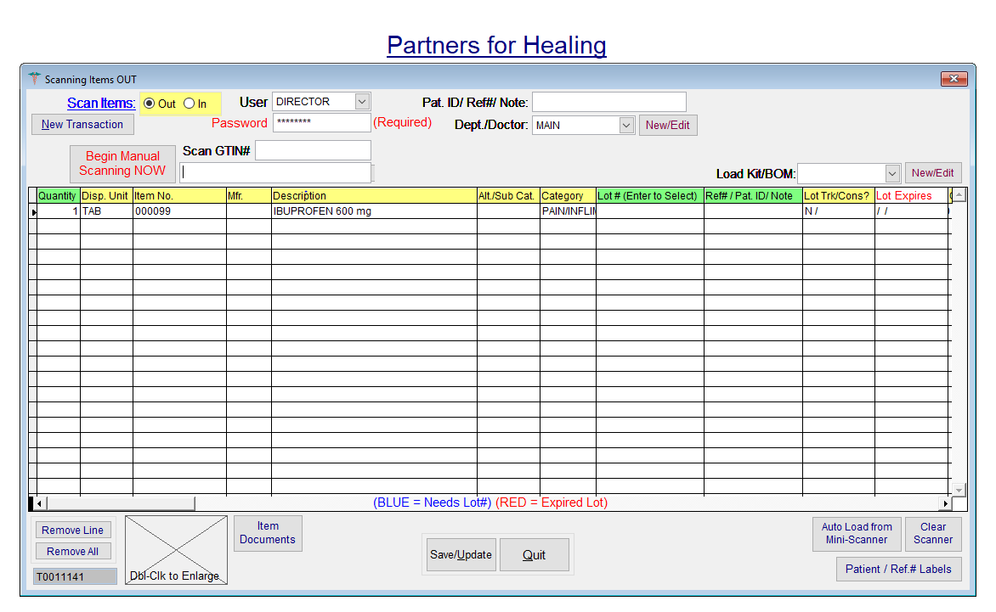
At this screen, enter the quantity dispensed and in the Ref#/Pat ID/Note field, enter the patient ID.
Once complete press Save/Update

To add a new PO, choose Vendors/Purchase Orders/Receiving from the main menu.

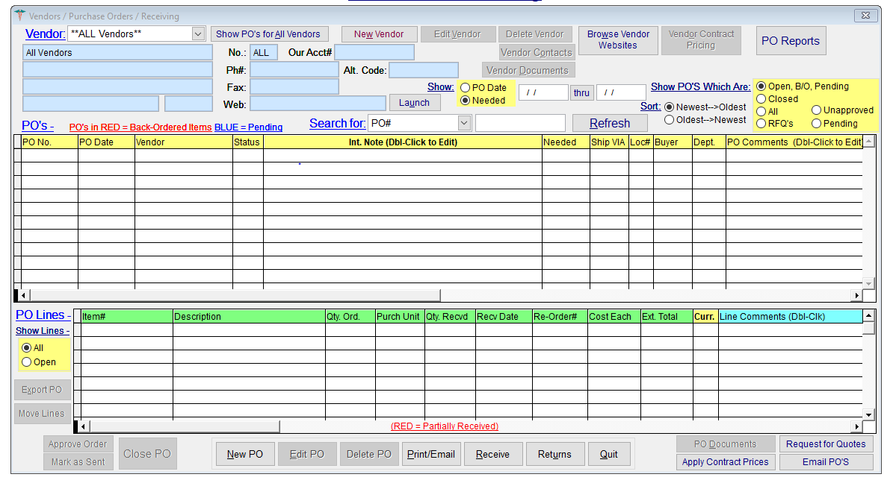
Select Vendor and New PO
Current vendors are:
- Americares
- Direct Relief
- Donation

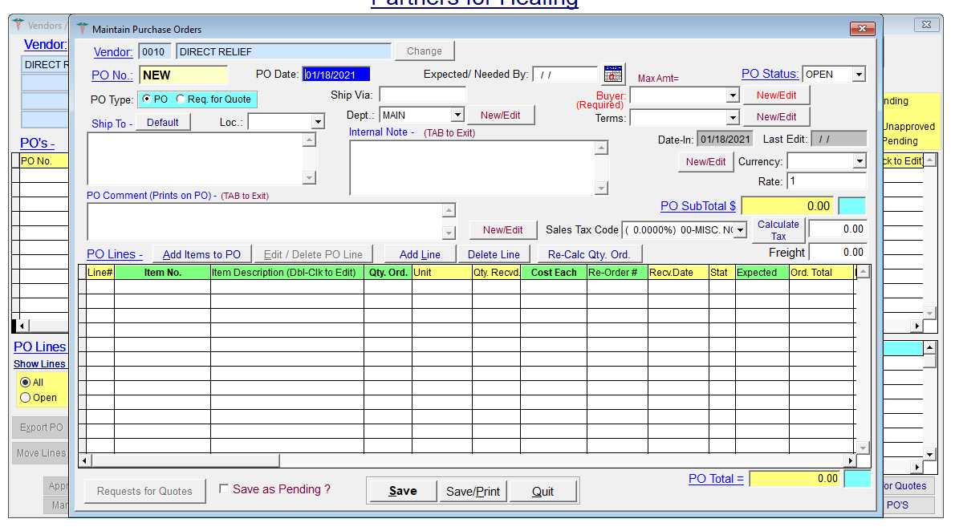
To add items select Add Items to PO

Choose item number to be added (all 6 digits must be included) via the search box
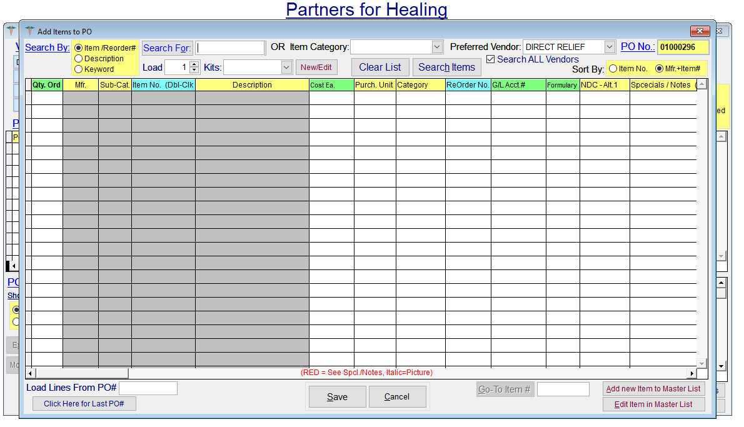
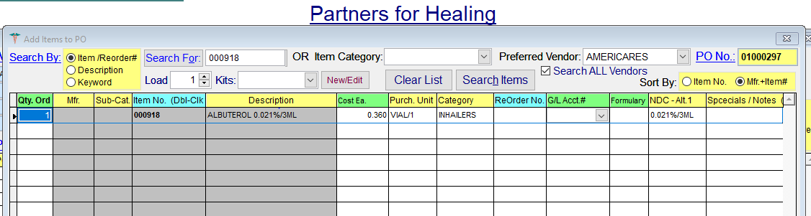
Information will be displayed. Update quantity to be added in Qty Ord column
When all items are entered, choose Save
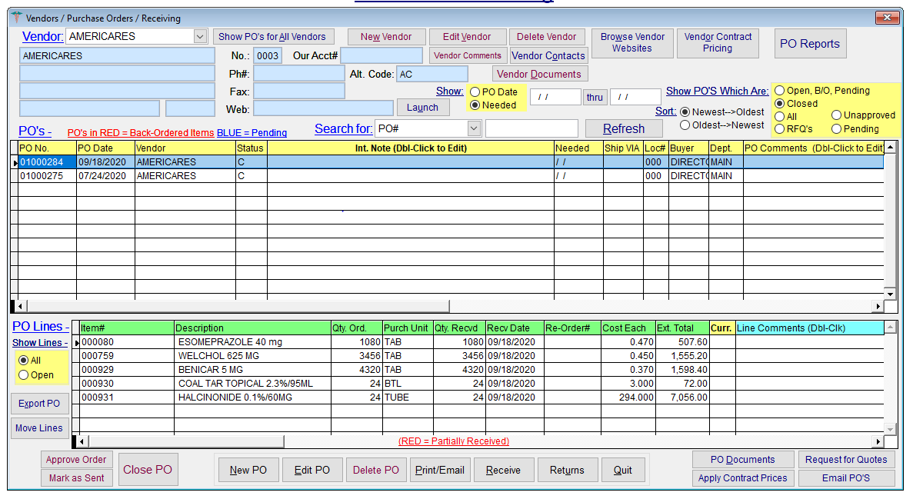
When complete print PO using Print/Email and provide to nurses in the med room

If the item is not currently in the system, it should be added from the Master Set up option on the main menu.
ADD NEW ITEM
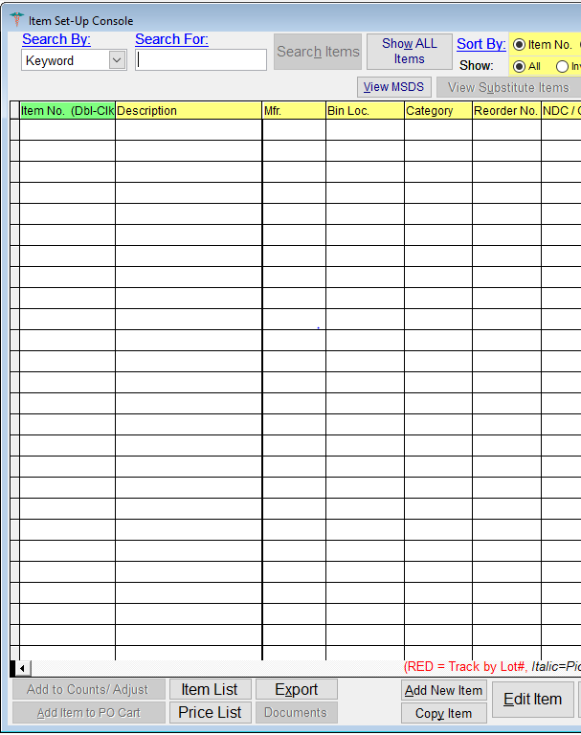
Choose Add New Item on this screen
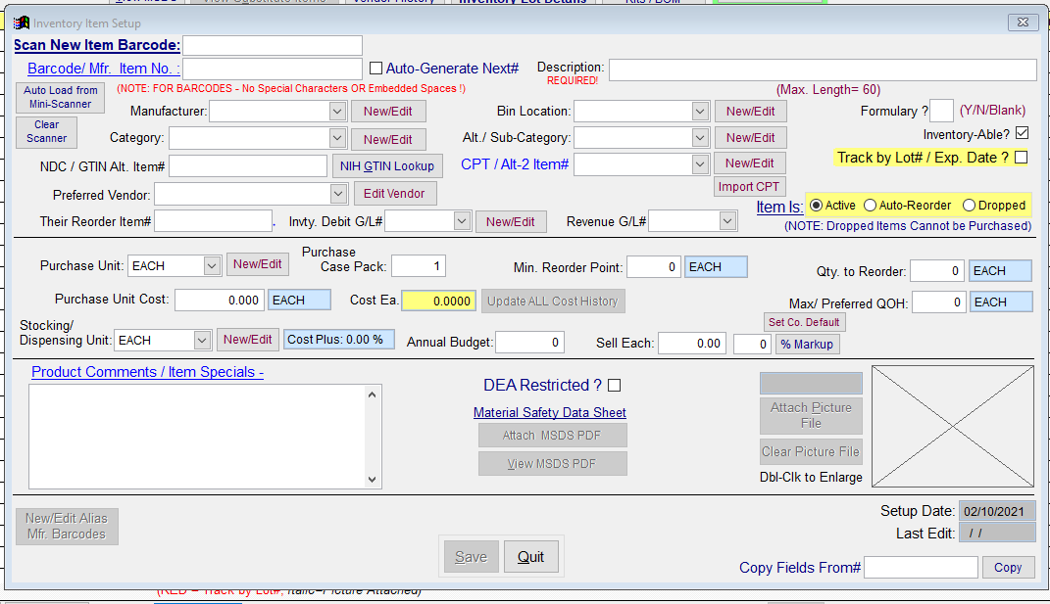
Select AUTO GENERATE NEXT#
Fill in fields marked:
DESCRIPTION
Include the medication name and dose
CATEGORY
  - ACID REFLUX/STOMACH
  - ACNE TOPICAL
  - ALLERGIC EMERGENCIES
  - ALLERGY/SINUS
  - ANESTHETIC
  - ANGINA
  - ANTI INFECTIVE
  - ANTIBIOTICS
  - ANTICOAGULATION
  - ARB
  - ANTIVIRAL
  - BIRTH CONTROL
  - BLOOD PRESSURE
  - BOWELS
  - CARDIOVASCULAR
  - CHOLESTEROL
  - DIABETES
  - DIURETIC
  - GASTROINTENSTINAL
  - GOUT
  - HORMONE
  - INHALERS
  - INJECTABLES
  - INSULIN
  - MIGRANE
  - NAUSEA
  - NEUROLOGY
  - OTHER
  - PAIN/INFLAMATION
  - PSHCY
  - SKIN/TOPICAL
  - THYROID
  - ULCERS
  - UROLOGY
  - VACCINE

NDC/GTIN ALT ITEM #
Include dosage in this field
PURCHASE UNIT (use the unit that will be dispensed to the patient)
  - BOX
  - BTL
  - CAN
  - CASE
  - EACH
  - IH
  - PACK
  - PEN
  - TAB
  - TUBE
  - VIAL
PURCHASE UNIT COST – this will be the unit cost of the medication based on the generic price on Good Rx at the cheapest local source.
STOCKING/DISPENSING UNIT (use the same as PURCHASE UNIT and make sure Case pack =1)
  - BOX
  - BTL
  - CAN
  - CASE
  - EACH
  - IH
  - PACK
  - PEN
  - TAB
  - TUBE
  - VIAL

When complete press SAVE. Screen will return to completed Item Setup Console
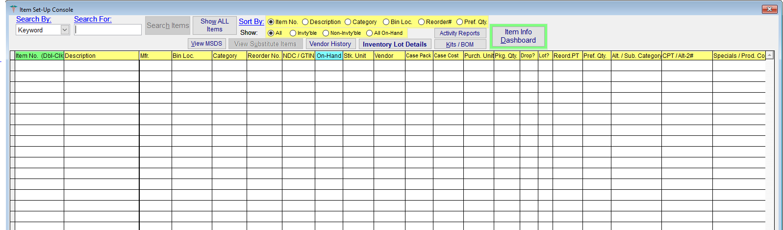

Receive PO
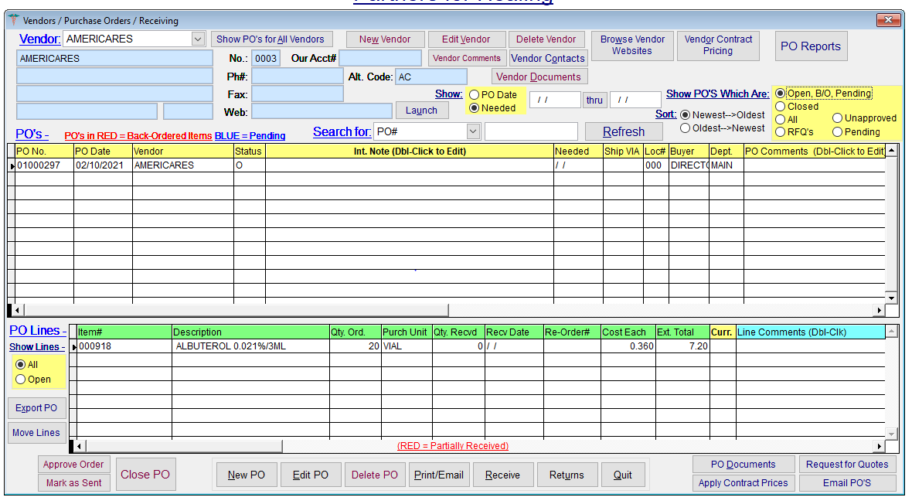
Select the Vendor and then the PO to be received
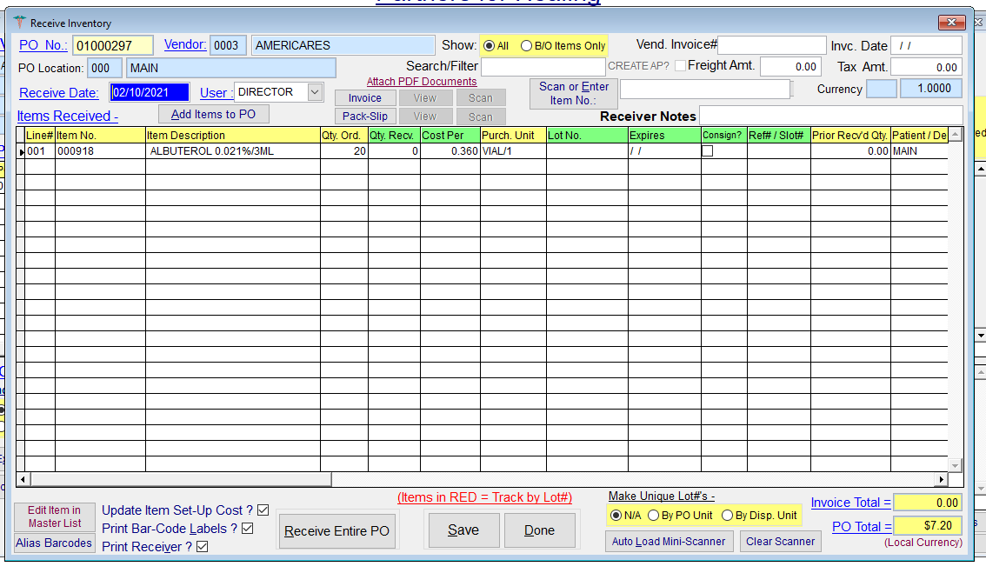
Verify all quantities are correct and choose Receive Entire PO. Or make any corrections if quantities do not match.
Then Save
Choose option to print the receiver report and put it with the packing slip into the folder for the correct vendor.

